Practice Activity: Create a spreadsheet with monthly expenses
Before You Begin
✅ Download all attached files.
✅ Save the files in your Office Fund folder before starting.

Purpose
For our first Excel assignment, we will create a spreadsheet of monthly expenses. This spreadsheet will provide us with an overall picture of our financial health by helping us understand where we are spending our hard-earned money.
Key skills in this practice include

- creating a new workbook
- entering text in a cell
- adding a formula to a cell
- formatting text
- print options and preview
- adding a footer
- page setup
- adjusting column width
- adding charts and sparklines
- using themes
- auto fill
- formatting cells

We will start with a new blank Excel Spreadsheet.
- Start Excel.
- Click Blank Workbook.
- Select File tab > Save As, and then navigate to your Office Fundamentals folder or other location where you save your files.
  - Name the Workbook as FirstL_Excel1 (example AynslieC_Excel1).

- Take a moment to locate the following components of the Excel Workbook window.
  - Notice how Columns are lettered and Rows are numbered.
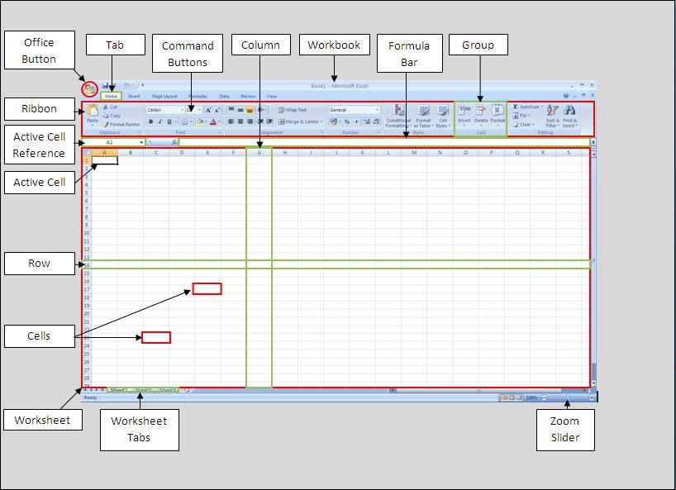
  - The intersection of a row and column is a cell.
https://msexcel07.blogspot.com/2011/04/1-introduction-to-excel-and-terminology.html
  - The active cell in the image is A1.
  - Notice the vertical and horizontal scroll bars. Use the arrows to practice scrolling on the page.

Adding Text/ Data in a Cell
- In cell A1, copy and paste "My Budget by Month" and press Enter.
- In cell A2, copy and paste "For the First Quarter" and press Enter.
- Starting in cell A4, copy and paste each of the following, pressing Enter after each:
Housing
Groceries
Utilities
Misc Expenses
Monthly Total

Using Fill Handles to Add Text / Data
- In cell B3, type January and press Enter.
- Select cell B3 and use the fill handle (small square in lower right corner of cell) to drag to cell D3.
  - Notice how the names of the months automatically generate.
  - The fill handle enables auto-fill, which generates and extends a series of values into adjacent cells based on the value of other cells.
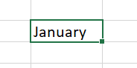
Fill handle

Adjusting Column Width
- Adjust the column width for column A to Width approximately 18.71 (136 pixels) by dragging the right boundary (between columns A and B) to the right.
  - Can also select the column, right-click, select Column width

Selecting a Range
- Select the range B3:D3 and center the text.
Note: A range in Excel is two or more cells on a worksheet that are adjacent (next to each other) or nonadjacent (not next to each other). To select nonadjacent ranges, use the CTRL key on your keyboard.

Using Formulas
- In cell B4, type 1200 and enter the remaining numbers as shown:
 | January | February | March
Housing | 1200 | 1200 | 1200
Groceries | 200 | 250 | 275
Utilities | 85 | 80 | 90
Misc Expenses | 20 | 50 | 30

- In cell B8, type =b4 + b5 + b6 + b7 and press Tab.
- In cell C8, type =c4 + c5 + c6 + c7 and press Tab.
Note: Using this technique we are manually entering a formula that sums a range of cells. Notice the Formula Bar as you enter in your formula. The formula bar displays the Underlying Formula.

Using the SUM Function
- A quicker way to enter a formula is with a function. We will use the SUM function next.
  - Select cell D8,
  - Home tab, > Editing group > click AutoSum icon (Σ) > press Enter.
- In cell E3, copy and paste “Total” and then press Enter.
- Select cell E4, Press Alt and +/= key.
  - This is a keyboard shortcut that enters the Sum function. If the keyboard shortcut does not work (this is common due to variations in keyboards), use the AutoSum technique from step 16.
- Click the Enter button on the Formula Bar, which is the green or blue check mark.

Using Fill Handles to Add Formulas to Cells
- With Cell E4 selected, drag the fill handle in cell E4 down through cell E8.
- Click in cell F3, type Trend and press Enter.
Formatting Cells
- Click within cell A1, and drag your cursor to the right to select the range A1:F1.
- Home tab, in the Alignment group, choose Merge and Center.
  - The title should be Merged and centered in the range A1:F1.
- Using the same technique, Merge and Center the title in the range A2:F2.

Formatting Text
- Select cell A1
- Home tab, Styles group, click arrow next to cell styles select Title style
- Select cell A2, apply the Heading 1 style
- Select range B3:F3, apply the Heading 4 style
- Select A4:A8 and click F4 to repeat the last command (Apply the Heading 4 style).
- Select B8:E8, apply Total style

Formatting Numbers
- Select noncontinuous ranges B4:E4 and B8:E8
- Home tab, Number group, select the arrow to view a drop-down list of all number format, apply the Accounting number format.
- Select the range B5:E7.
- Home tab, Number group, and select the Comma Style icon

Autofit Column Width
- Select column D by clicking on the D Column Header.
- Double click the line between the D and E.
  - Or, select Column D, on the Home tab, Cells group, click the arrow next to Format and choose AutoFit Column Width.

Applying Themes
- Page Layout tab, in the Themes group, click the arrow under Themes, choose Slice
  - If necessary, adjust the width of the columns to ensure you can see all of the cell content.

Adding and Adjusting Charts
- Select the range A3:D7.
- Insert tab, Charts group, click Recommended Charts, click All Charts, select Clustered Column chart and then click OK.
- With the chart selected, under the Chart Design tab, Chart Layouts group, Choose the Add Chart Element and ensure the Chart Title is ‘Above Chart’.
- Change the Chart Title to My Budget (copy and paste).
- Move the chart so that the upper left corner is inside cell A10 by clicking and holding any of the borders using the four-sided arrow mouse pointer.
- Ensure the chart is still selected, Chart Design tab, under Chart Styles group, click the down arrow, select Style 6
- Chart Design tab, under Chart Styles group, click the arrow near Change Colors, select Colorful Palette 4.

Insert and Edit a Sparkline
- Select the range B4:D4. DO NOT include the totals in the sparkline range.
- On the Insert tab, Sparklines group, then choose Line
  - Ensure the Data Range is B4:D4
  - Type F4 in the Location Range textbox and click OK enter.
- With cell F4 selected, on the Sparklines tab, in the Show group, choose the checkbox next to Markers.
- On the Sparkline tab, Style group, click the arrow to see all the styles, select the Dark Green, Sparkline Style Accent #4, Darker 25% style (or similar).
- With cell F4 selected, use the fill handle to fill the sparkline to cells F5:F7.

Editing the Page Layout
- On the Page Layout tab, Sheet Options group, click the arrow to launch the Page Setup dialog box.
- Go to the Margins tab, click the checkbox to center the data and chart horizontally on the page.
- Go to the Header/Footer tab, select Custom Footer, click on the Left Section, and insert the File Name (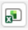), click OK.
  - This is a field, so if the file name is changed, it will automatically update the footer with the new file name.
- Go to the Page tab, under Orientation, select Landscape
- Under Scaling, select Fit to, 1 pages(s) wide by 1 tall is selected.
- Click Print Preview to see how the sheet will print
- Click the back arrow to exit Print Preview

Printing Options
- Select the range A2:F5
- Click the File tab, select Print
- Change Settings to Print Selection from drop down list and notice how the Print Preview changes.
  - Printing of this assignment is not required, but if you needed to print a copy, you would click Print.
- Click the back arrow to exit Print Preview

Showing Formulas
- On the Formulas tab, Formulas Auditing group, click Show Formulas.
  - This is a toggle button
  - Notice how Row 8 and Column D display the formulas rather than the result .
  - Turn Show Formulas off.

Spell Check and Final Checks
- Review tab, Proofing group, click Spelling, and make any spelling corrections as necessary.
- Compare your file to the images below and make all necessary corrections.
  - Worksheet view
  - Print Preview view
- Submit as instructed by your instructor.
